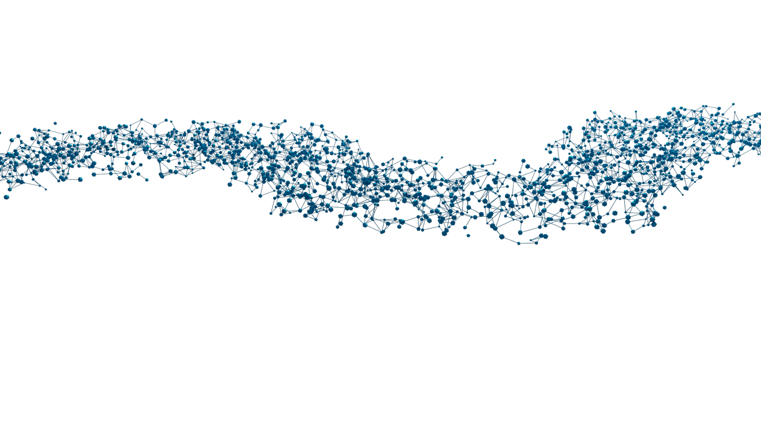

Standard BRB-seq Service

Sample Preparation and
Submission Guidelines

December 2025

MERCURIUS™

BRB-seq for 96- and 384-well Plate Format

Sample submission guidelines at a glance
- Transfer the RNA samples to a 96- or 384-well PCR plate following the instructions below and store them at -80°C before shipment.
- Fill in the Sample Submission Form (SSF) and check all the boxes in the Sample submission checklist below; send both files to orders@alitheagenomics.com. Please be aware that any inconsistency may lead to delays or additional fees.
- Request the shipping address from your sales specialist.
- Ship the samples on dry ice, ensuring the plates are placed between layers of dry ice to maintain a consistent freezing temperature throughout transit. Please provide us with the shipment tracking number.

Sample submission checklist
- The Sample Submission Form (SSF) must be filled out correctly with a unique sample ID. Consider adding a suffix for technical replicates (e.g., XX_rep1, XX_rep2, etc.). Ensure that the SSF provides information about all the shipped samples
- Avoid having randomly distributed samples across the plate layout (e.g., in A01, A06, B03, G10-12, etc.).
- The sample volume should be 15 µL per well and identical for all samples (!).
- The concentration of all samples is uniform, and the A260/230 ratio is assessed and provided in the SSF.
- The minimum number of samples in each group (to be pooled together) is 16.
- Samples are provided in the 96-well RNase/DNase-free PCR plate. Samples in tubes cannot be processed.
- Plates are labeled with the same Plate ID as indicated in the SSF.
- Plates are well sealed with an adhesive and a temperature-resistant seal (aluminum is ideal).

Essential considerations for input material

Samples quantity and integrity
- The tested range of total RNA amount is 200 – 1000 ng (per well).
- The minimum volume should be 15 µL.
- The sample concentration should be at least 12 ng/µL.
- The recommended RIN number is > 6.

Samples purity
- RNA samples extracted with TRIzol, phenol, chloroform, or guanidine are prone to residual contamination with organic solvents that considerably decrease cDNA yield.
- To ensure the high purity of RNA, assess the 260/230 ratio for all samples.
- The 260/230 ratio values should be between 1.8 and 2.2.

Samples uniformity
- To ensure an even distribution of reads after sequencing, the RNA amount, integrity, and 260/230 values of the starting RNA samples must be as uniform as possible, with a max 10% variation.
- To obtain such uniform amounts, we recommend the following:
- Use dye-based methods for RNA quantification (e.g., Qubit Quant-iT or RiboGreen).
- Dilute samples to obtain the same RNA concentration in all wells (±10%).
- Re-measure the RNA concentration of all samples to confirm uniform concentration.
- Ensure the 260/230 ratio is between 1.8 and 2.2. and the RIN value is > 6 across the samples.

Batch-effect and sample replicates
- RNA extraction protocol can produce considerable technical variation across the samples; therefore, performing RNA extraction in a single batch is strongly recommended.
- If the differential expression (DE) analysis is planned, the respective RNA samples should be included in the same library. Comparison of samples from different libraries can be biased.
- Including at least 3 (or more) biological replicates is highly recommended for the reliability of the experimental setup.

Samples preparation
- Label a new 96- or 384-well RNase/DNase-free PCR plate.
- Pipette the RNA samples to the new 96- or 384-well PCR plate according to the filled Sample Submission Form. Follow the column-based direction (column 1, then column 2, etc.).
- Seal the 96- or 384-well PCR plate with an aluminum seal and briefly spin it down.
- Store the samples at -80°C before shipment.
Alithea Genomics SA
Phone
+41 78 830 31 39
Email
info@alitheagenomics.com
Web
www.alitheagenomics.com
Address
Route de la Corniche, 8
1066 Épalinges
VD, Switzerland
Phone
+41 78 830 31 39
Email
info@alitheagenomics.com
Web
www.alitheagenomics.com
Address
Route de la Corniche, 5
1066 Épalinges
VD, Switzerland

